Ques 3 : Deploy an AKS cluster using the portal. Access the dashboard and create roles for multiple users

SOLN:

GO TO AZURE KUBERNETES CONTAINER SERVICES AND CREATE ONE :

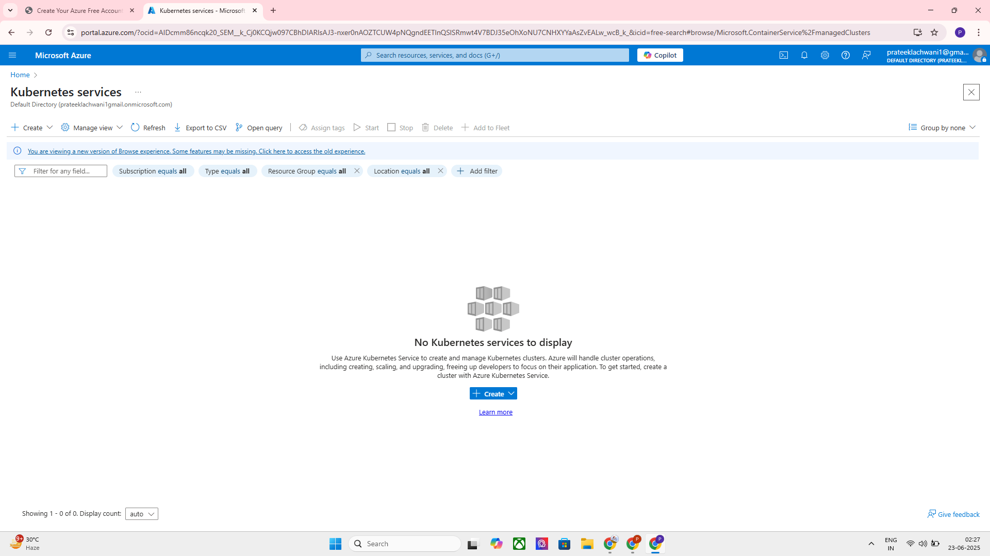

MAKE SURE TO VERIFY THE CONFIGURATIONS :
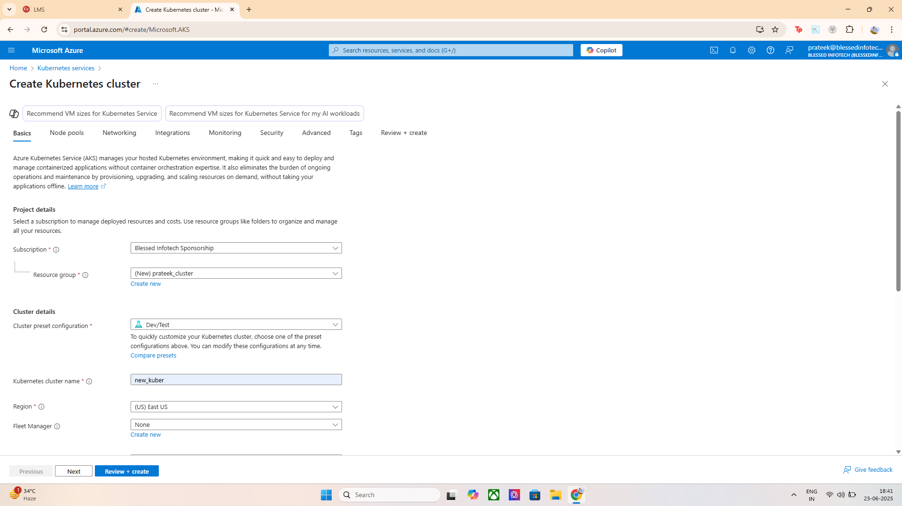
SET THE NODE PODS AND THE CONTAINER VM CONFIGURATION AS PER THE ZONE :

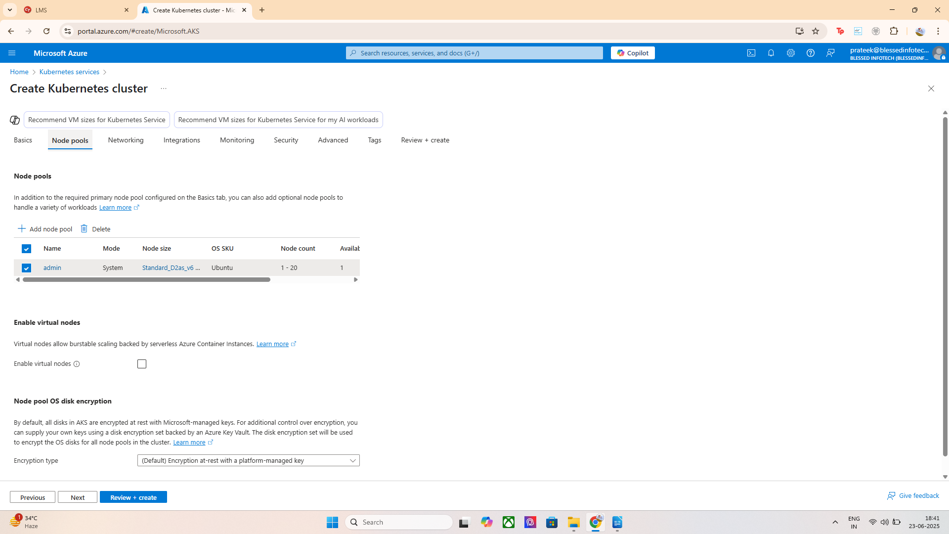
REVEIW AND CREATE A KUBERNETES CLUSTER

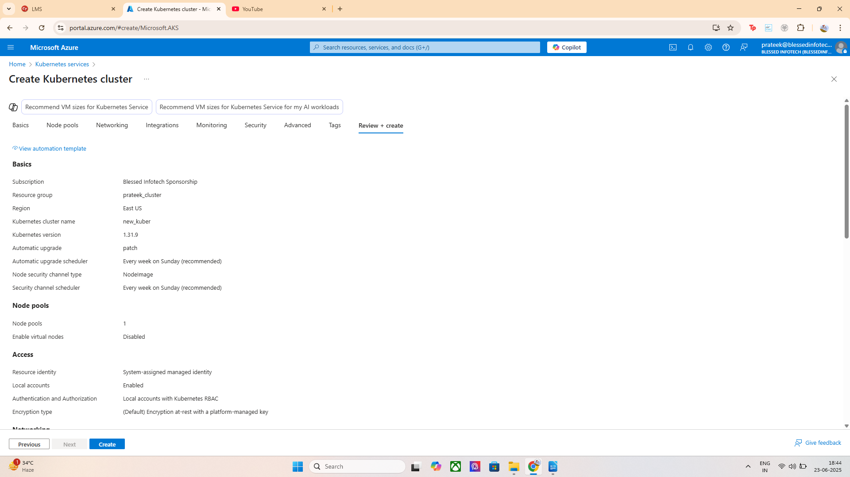
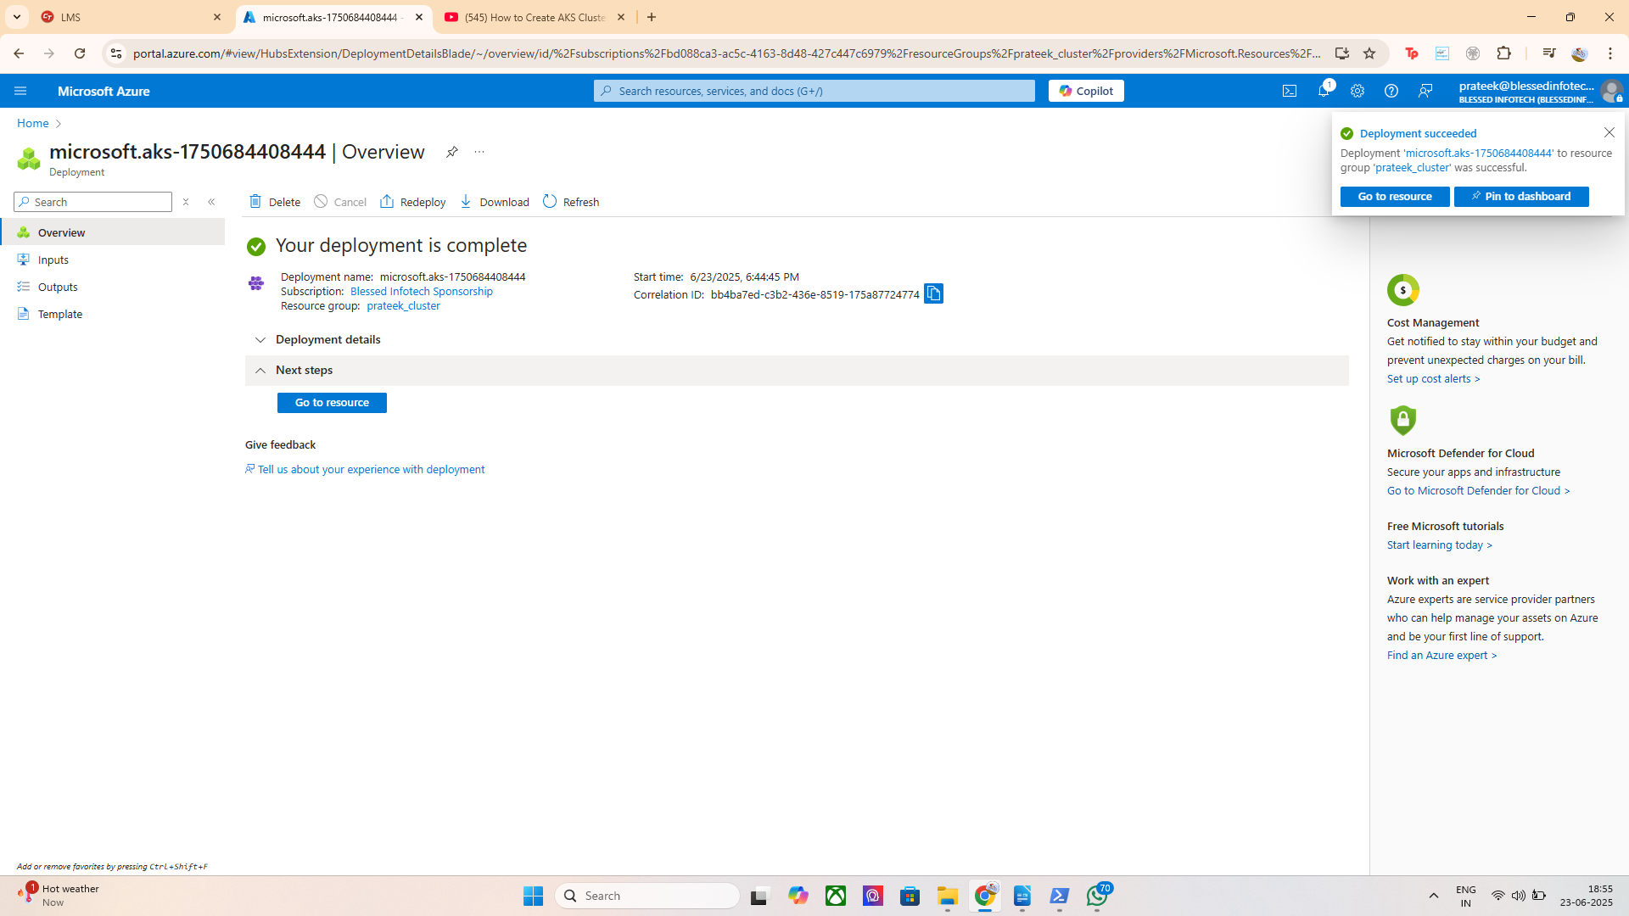
VERIFY THE DEPLOYMENT:

CREATED AND ACCESSED THE NEW_CLUSTER

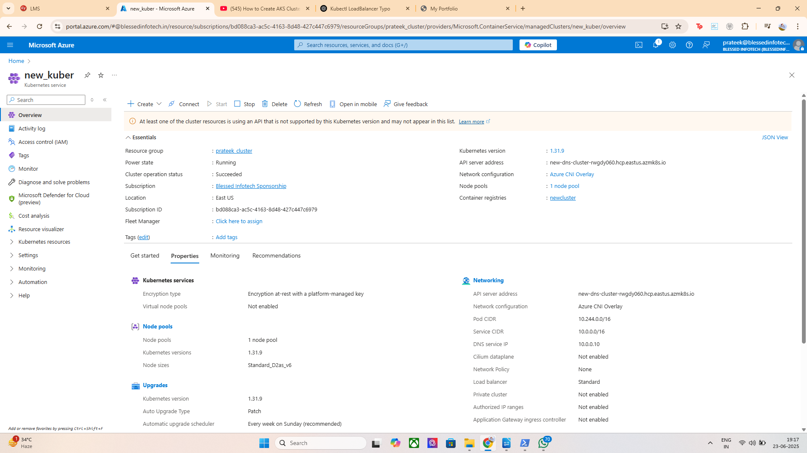

COMMAND USED : az configure --defaults group=prateek_cluster
az aks get-credentials --name new_kuber
kubectl config current-context
kubectl get nodes

az configure --defaults group=prateek_cluster
➤ Sets the default Azure resource group to prateek_cluster for future az commands.
- az aks get-credentials --name new_kuber
➤ Downloads the kubeconfig for the new_kuber AKS cluster and merges it into your local ~/.kube/config.
- kubectl config current-context
➤ Verifies that your kubectl is now set to use the new_kuber cluster.
- kubectl get nodes
➤ Lists all nodes in the cluster, confirming that the cluster is running and ready.

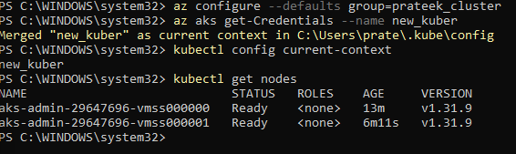

COMMAND USED : kubectl get deployments
kubectl get pods

Explanation (for your DevOps project report)
- kubectl get deployments
➤ Lists all Kubernetes deployments in the current namespace (defaults to default).
📌 Output: “No resources found in default namespace” — means no deployments exist there yet.
- kubectl get pods
➤ Lists all pods in the default namespace.
📌 Output: “No resources found” — confirms no running workloads currently exist in default.

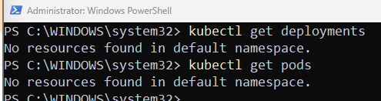

.

.

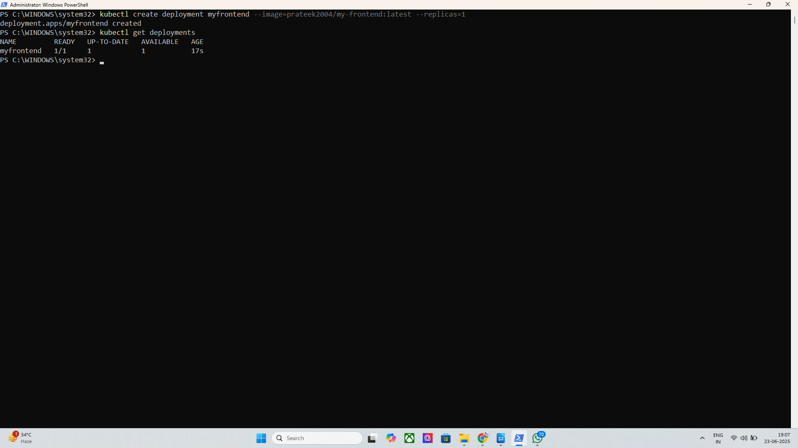
LETS CREATE A DEPLOYMENT AROUND MY FRONTEND

COMMAND USED :

kubectl create deployment myfrontend --image=prateek2004/my-frontend:latest --replicas=1
kubectl get deployments
kubectl get pods
kubectl expose deployment myfrontend --type=LoadBalancer --port=80 --target-port=80
kubectl get svc

Explanation (3–4 lines for your report)
A custom frontend container was deployed to the AKS cluster using kubectl create deployment with a public Docker image.
It was then exposed via a LoadBalancer service to make it accessible externally.
The external IP 172.212.79.224 allowed public access to the app.

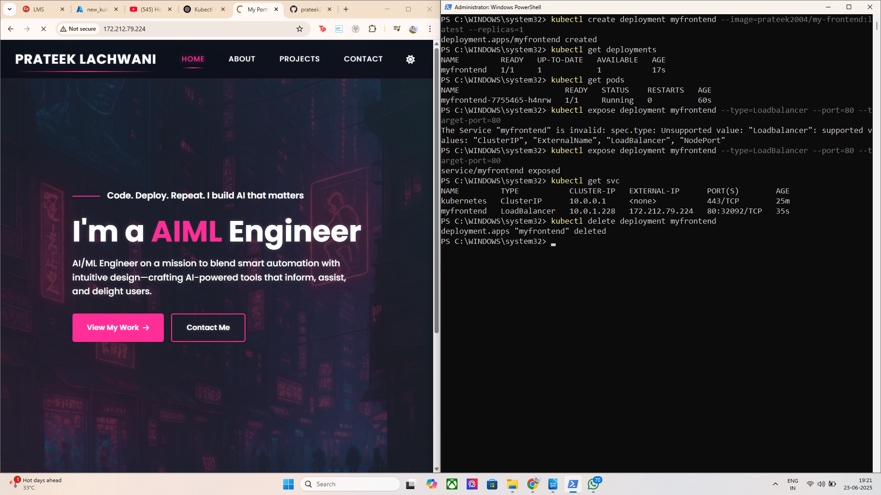
CONFIGURE THE DASHBOARD TO THE TERMINAL

COMMAND USED :

kubectl apply -f https://raw.githubusercontent.com/kubernetes/dashboard/v2.7.0/aio/deploy/recommended.yaml

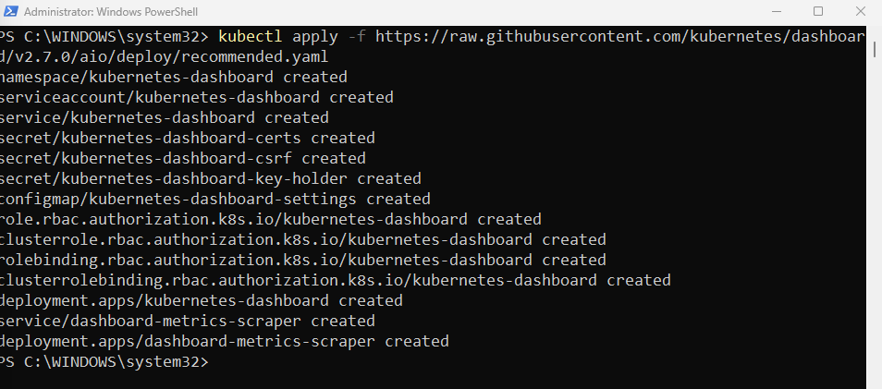
command to access the dashboard

kubectl proxy
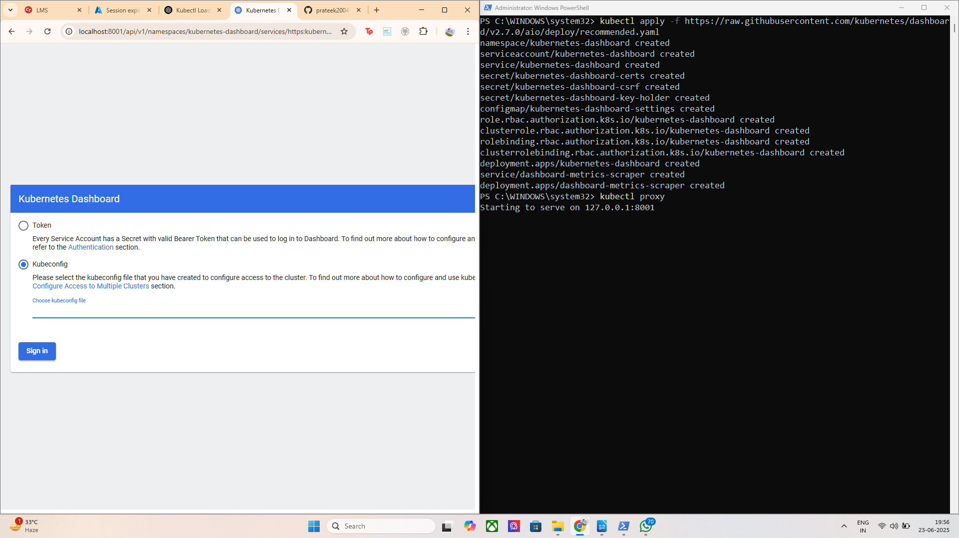

PART B

Lets Create Service Accounts & Roles for Users

Create YAMLs for the following:

a. Viewer (Read-only access):
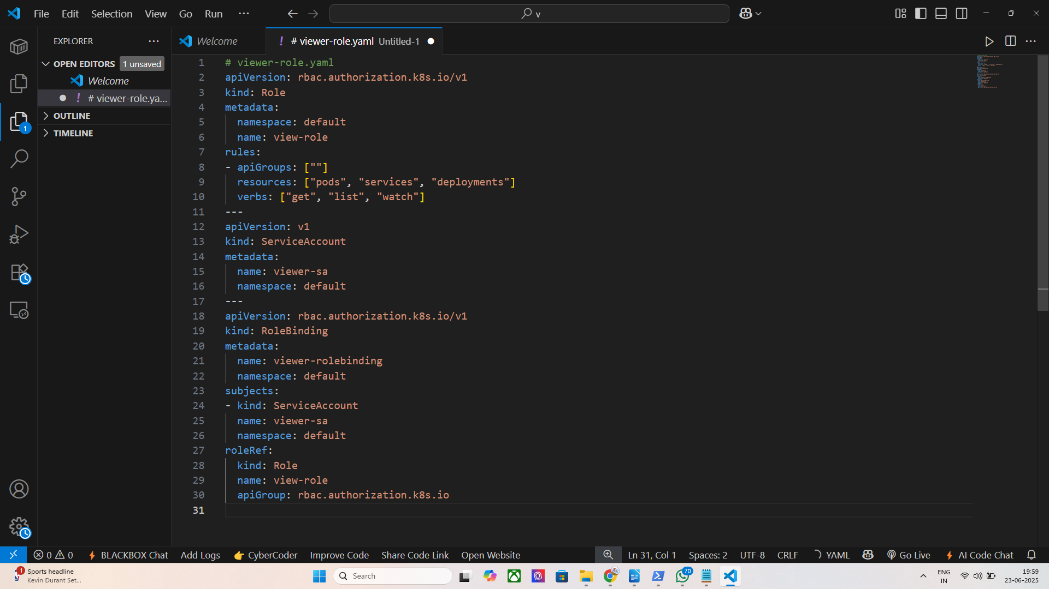
Save it as veiwer_role.yaml

and in the terminal change directory to the created path
and run command : kubectl apply -f viewer-access.yaml

Get the Token to Log In

command used : kubectl -n kubernetes-dashboard describe secret $(kubectl -n kubernetes-dashboard get secret | findstr viewer)
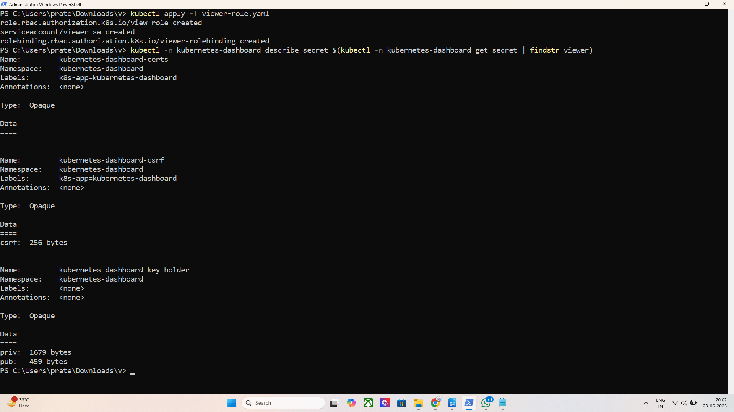
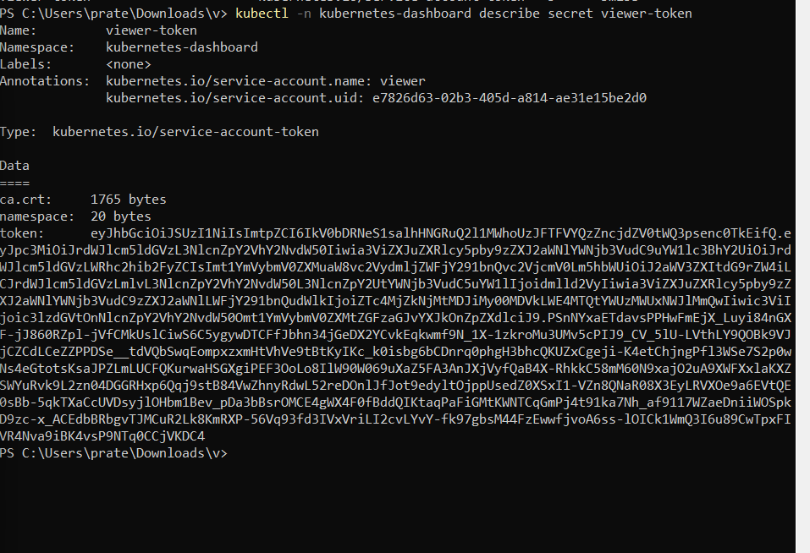
.

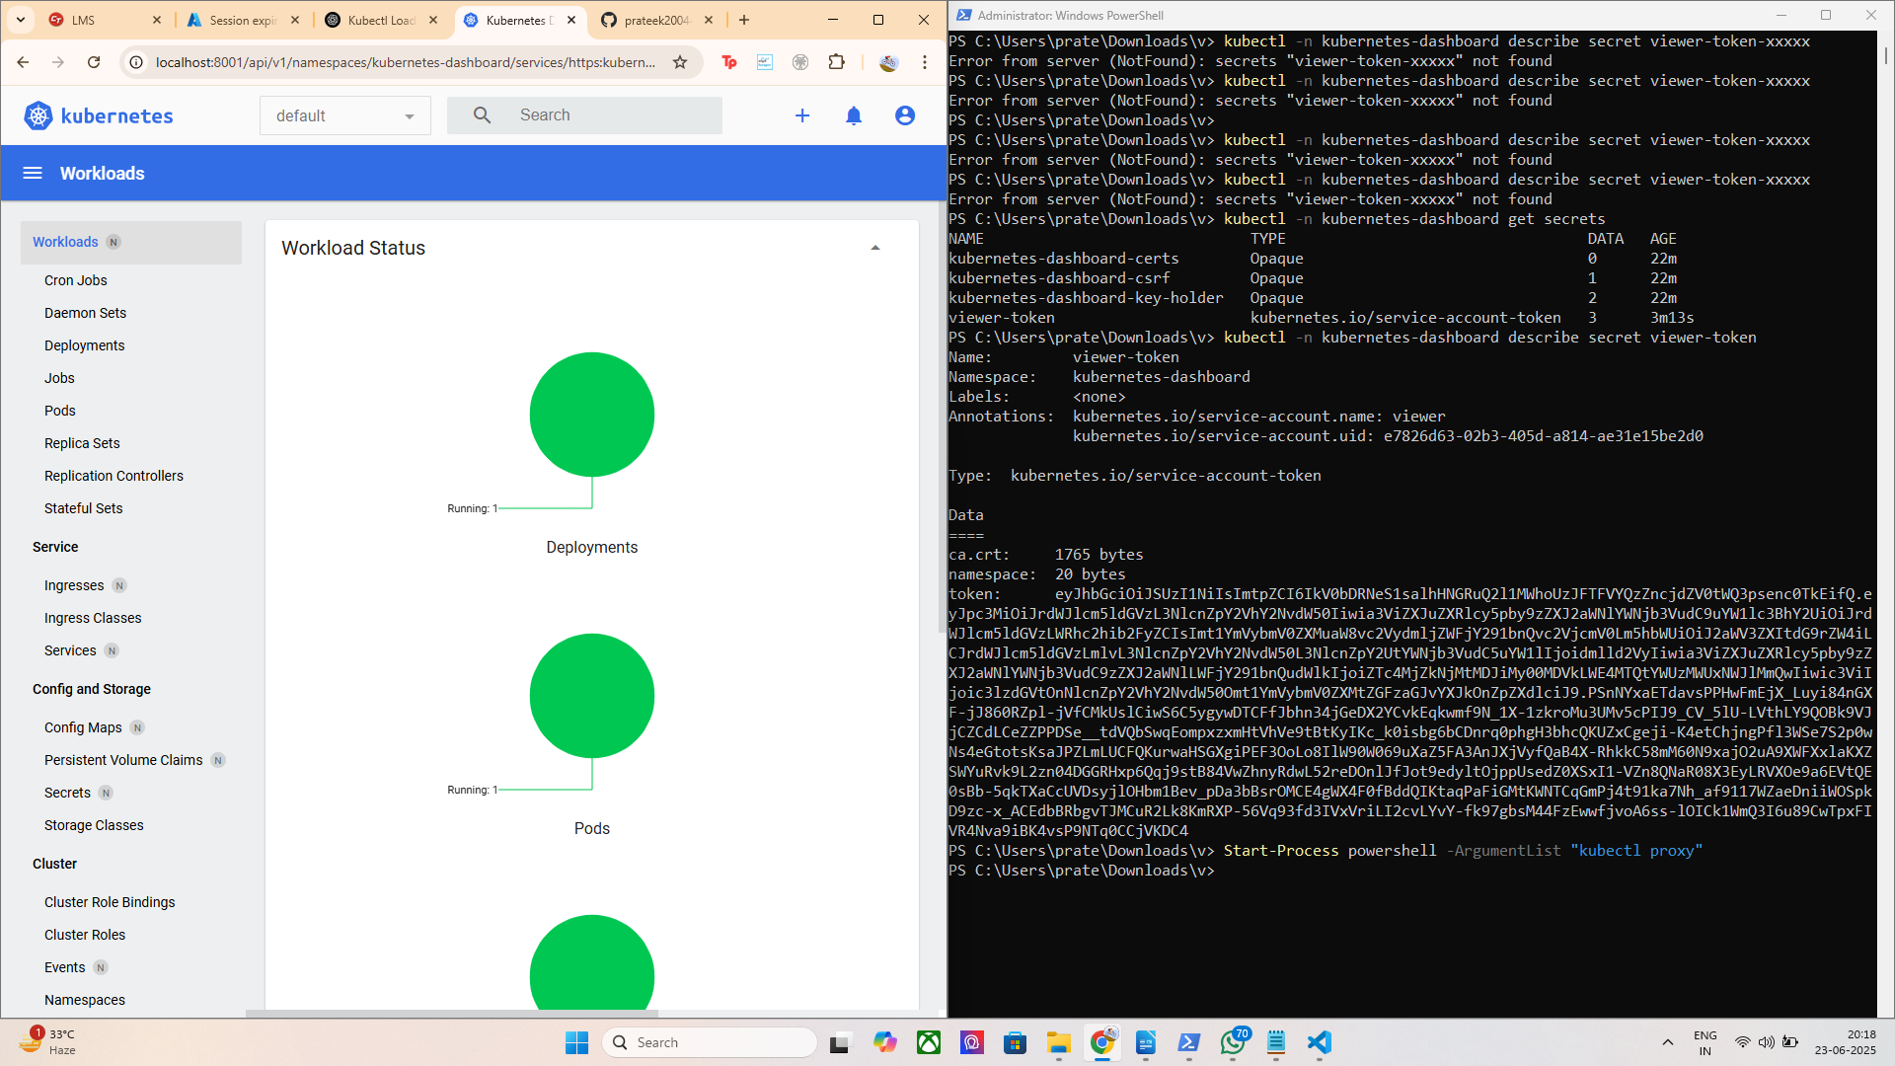
DASHBOARD SUCCESSFULLY ACCESSED USING ONLY VEIWER ROLE

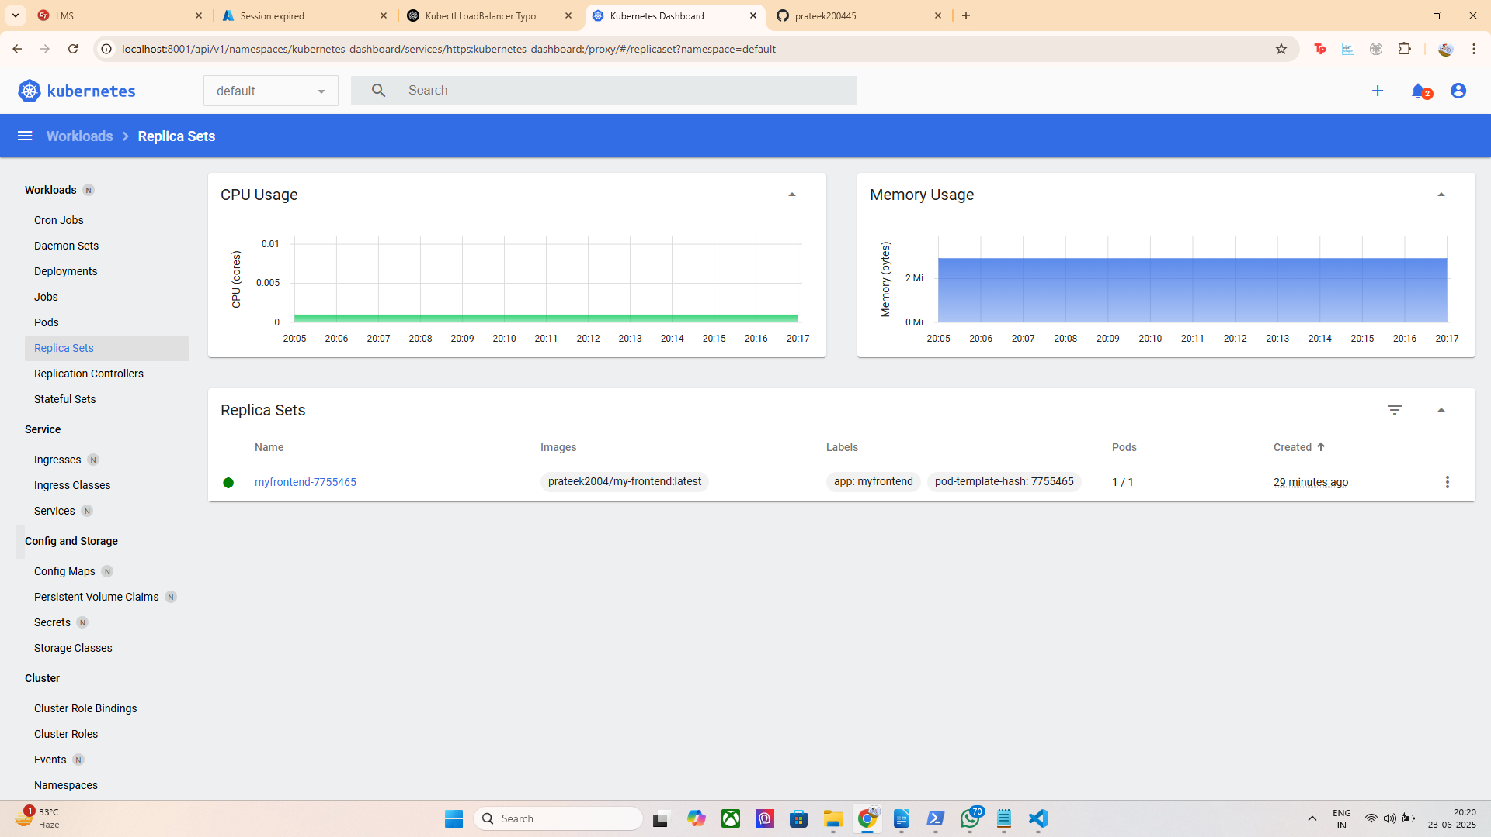

LETS CREATE DASHBOARD FOR DEVELOPER

Step-by-Step YAML: dashboard-developer-access.yaml

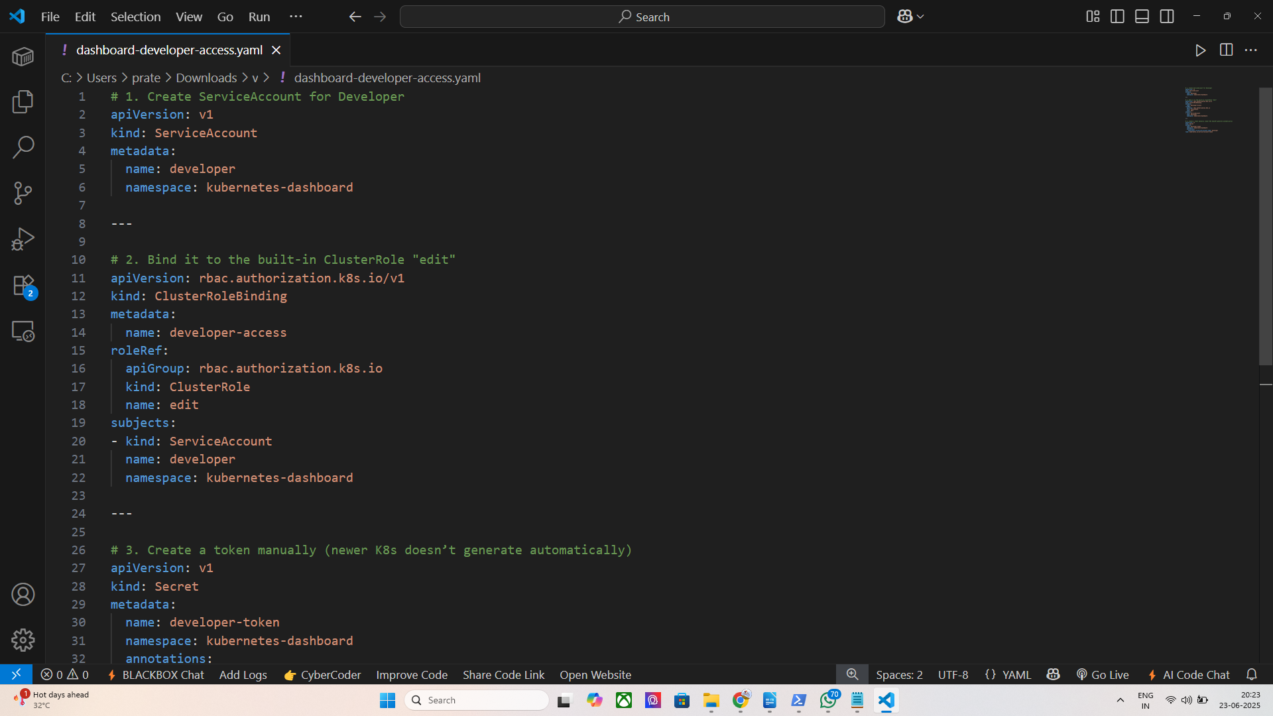

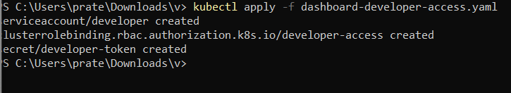

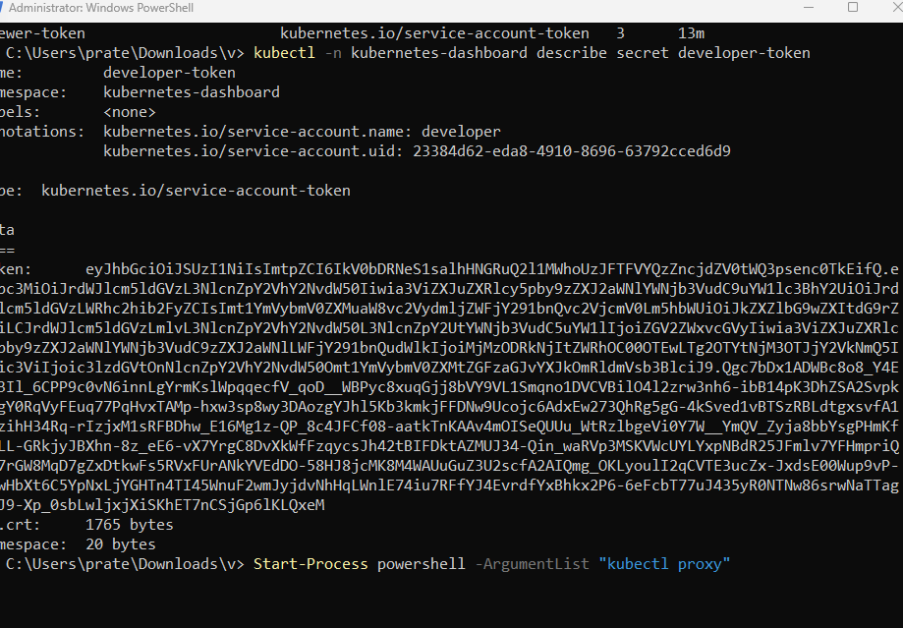

http://localhost:8001/api/v1/namespaces/kubernetes-dashboard/services/https:kubernetes-dashboard:/proxy/

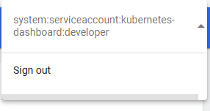

TO LEARN MORE ABOUT Real-world use case for multi-user RBAC in AKS.

Deploy a sample app (like nginx or your own frontend) and restrict who can see it.

Step 1: Deploy the nginx App in a Separate Namespace

Create dev namespace:

kubectl create namespace dev

Deploy OWNFRONTEND/NGINX in that namespace:

kubectl create deployment nginx --image=nginx --namespace=dev
You can verify:

kubectl get pods -n dev

Step 2: Restrict Access to dev Namespace
By default, users with the view or edit ClusterRoleBinding have access to all namespaces.
So instead, we’ll:
- Remove or not use ClusterRoleBinding
- Use Role + RoleBinding in dev namespace only

Step 3: Configure RBAC to Restrict Access

Create role access only for developer in dev namespace

📄 dev-namespace-developer-access.yaml:

# 1. Role with edit permissions in "dev" namespace
apiVersion: rbac.authorization.k8s.io/v1
kind: Role
metadata:
namespace: dev
name: developer-edit
rules:
- apiGroups: ["", "apps", "extensions"]
resources: ["pods", "services", "deployments", "replicasets"]
verbs: ["get", "list", "create", "update", "delete", "watch"]

---

# 2. Bind developer SA to this Role
apiVersion: rbac.authorization.k8s.io/v1
kind: RoleBinding
metadata:
name: developer-edit-binding
namespace: dev
subjects:
- kind: ServiceAccount
name: developer
namespace: kubernetes-dashboard
roleRef:
kind: Role
name: developer-edit
apiGroup: rbac.authorization.k8s.io

Step 4: Restrict viewer From dev Namespace
If you used a ClusterRoleBinding for viewer, it already has access to all namespaces.
To restrict it:
- Delete that binding:

kubectl delete clusterrolebinding viewer-access
- Recreate access only for default namespace:

viewer-default-access.yaml
yaml

apiVersion: rbac.authorization.k8s.io/v1
kind: Role
metadata:
name: viewer-read
namespace: default
rules:
- apiGroups: [""]
resources: ["pods", "services", "deployments"]
verbs: ["get", "list", "watch"]

---

apiVersion: rbac.authorization.k8s.io/v1
kind: RoleBinding
metadata:
name: viewer-read-binding
namespace: default
subjects:
- kind: ServiceAccount
name: viewer
namespace: kubernetes-dashboard
roleRef:
kind: Role
name: viewer-read
apiGroup: rbac.authorization.k8s.io
Apply it:

kubectl apply -f viewer-default-access.yaml

Final Behavior:
User | Namespace Access | Permissions
viewer | default only | Read-only
developer | dev only | Full app management

HENCE ITS SUCCESSFULLY VERIFIED

- Log in as viewer → you’ll see only default resources
- Log in as developer → you can manage nginx/MYFRONTENDDeploy an AKS cluster using the portal. Access the dashboard and create roles for multiple users

I successfully deployed and exposed a microservice application on AKS using all three service types, completing both: http://172.212.79.224
- ✅ Task 4: Microservice deployment on AKS with public access
- ✅ Task 5: Service exposure using ClusterIP, NodePort, and LoadBalancer

Objective:
To deploy a frontend microservice on Azure Kubernetes Service (AKS) and expose it using all three Kubernetes service types — ClusterIP, NodePort, and LoadBalancer. This validates application hosting, access control, and cloud-native service exposure.

Steps I Followed to Complete the Task:

Step 1: Set Up Access to AKS Cluster
I first connected my terminal to my AKS cluster named new_kuber using Azure CLI:

az configure --defaults group=prateek_cluster
az aks get-credentials --name new_kuber
kubectl config current-context
Then I verified the nodes were running:

kubectl get nodes

Step 2: Deploy a Microservice (Custom Frontend)
I used my custom Docker image hosted on Docker Hub (prateek2004/my-frontend:latest) to deploy a microservice with 1 replica:

kubectl create deployment myfrontend --image=prateek2004/my-frontend:latest --replicas=1

To verify the deployment:

kubectl get deployments
kubectl get pods

Step 3: Expose the App via LoadBalancer (Public Internet)
To access the application publicly, I exposed it using a LoadBalancer service:

kubectl expose deployment myfrontend --type=LoadBalancer --port=80 --target-port=80
kubectl get svc
Output:

NAME TYPE CLUSTER-IP EXTERNAL-IP PORT(S)
myfrontend LoadBalancer 10.0.X.X 172.212.79.224 80:32XXX/TCP
I then opened the public IP http://172.212.79.224 in the browser and successfully viewed my personal portfolio web page.

Step 4: Expose the App via ClusterIP (Default Service)
For internal-only service communication (used inside the cluster), I exposed the same deployment as a ClusterIP:

kubectl expose deployment myfrontend --type=ClusterIP --port=80 --target-port=80
ClusterIP is the default service type and allows internal traffic routing only.

Step 5: Expose the App via NodePort (Node-Level Port Mapping)
To simulate edge routing without cloud load balancing, I exposed the app via NodePort:

kubectl expose deployment myfrontend --type=NodePort --port=80 --target-port=80
kubectl get svc
Sample Output:

myfrontend NodePort 10.0.X.X <none> 80:30036/TCP
Though direct node IP access may be limited in AKS, this demonstrates how services can be mapped to static ports on every node.

